Load Balancer Task

1.Configure Classic Load Balancer.

TITLE:

Classic Load Balancer

OBJECTIVE:

To distribute incoming traffic to multiple EC2 instances and to improve the availability.

PREREQUISITES:

Two EC2 instances with some service running in it.

STEP-BY-STEP-IMPLIMENTAION:

These are two instances with httpd running in it.

Created a classic load balancer

Attached these two instances in target instances

Now test with domain name of load balancer in browser

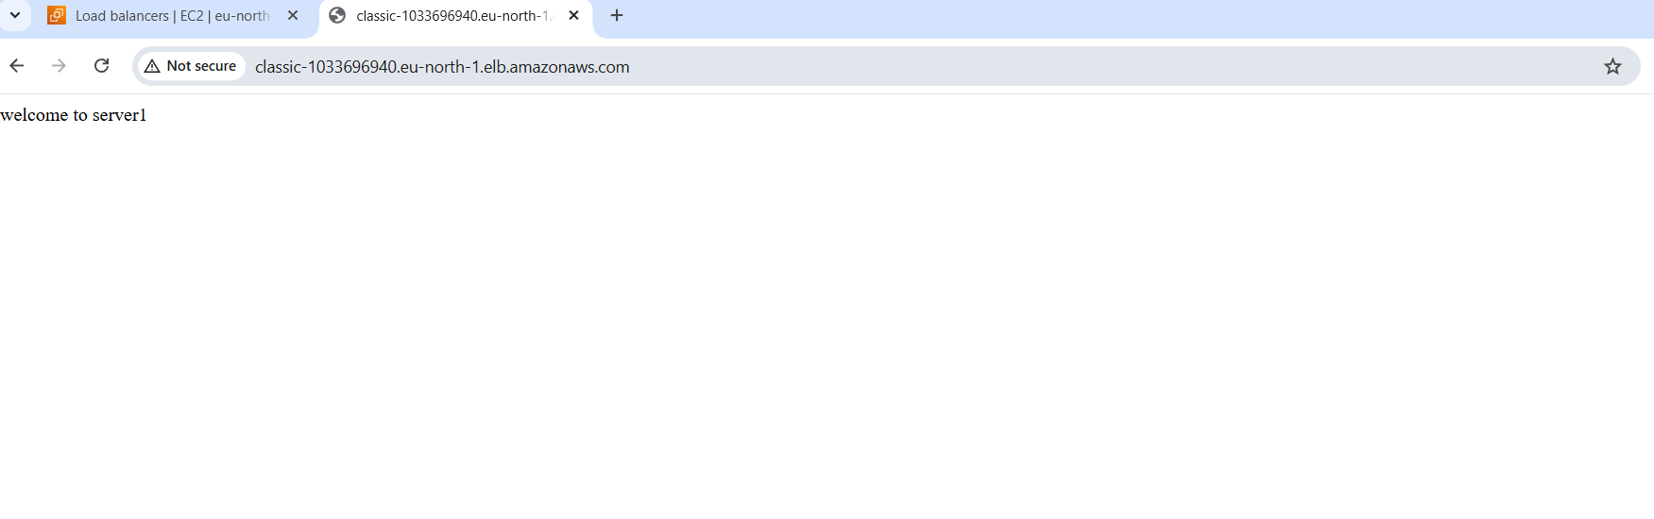

CONCLUSION: Configuring a Classic Load Balancer enables reliable distribution of incoming traffic across instances, improving application availability and fault tolerance.

2.Configure Application Load Balancer.

TITLE:

Application Load Balancer

OBJECTIVE:

To distribute incoming application traffic across multiple targets to ensure high availability, scalability.

PREREQUISITES:

EC2 instances

Target group

Application load balancer

Roles

STEP-BY-STEP-IMPLEMENTATION:

Here are the instances with httpd service running on it

Target group created

Application load balancer created

Role created

Now check in browser with load balancer DNS and along with role we attached.





CONCLUSION: An Application Load Balancer intelligently routes HTTP/HTTPS traffic based on content, improving application scalability, availability, and security.

3.Configure a Network Load Balancer.

TITLE:

Network Load Balancer

OBJECTIVE:

To distribute high-volume, low-latency network traffic across multiple targets at the transport layer while maintaining extreme performance and availability.

PREREQUIISTES:

EC2 instances with any service running in it.

Target group

Network load balancer

STEP-BY-STEP-IMPLIMENTATION:

Here are the two EC2s with httpd running in it.

Created Target group

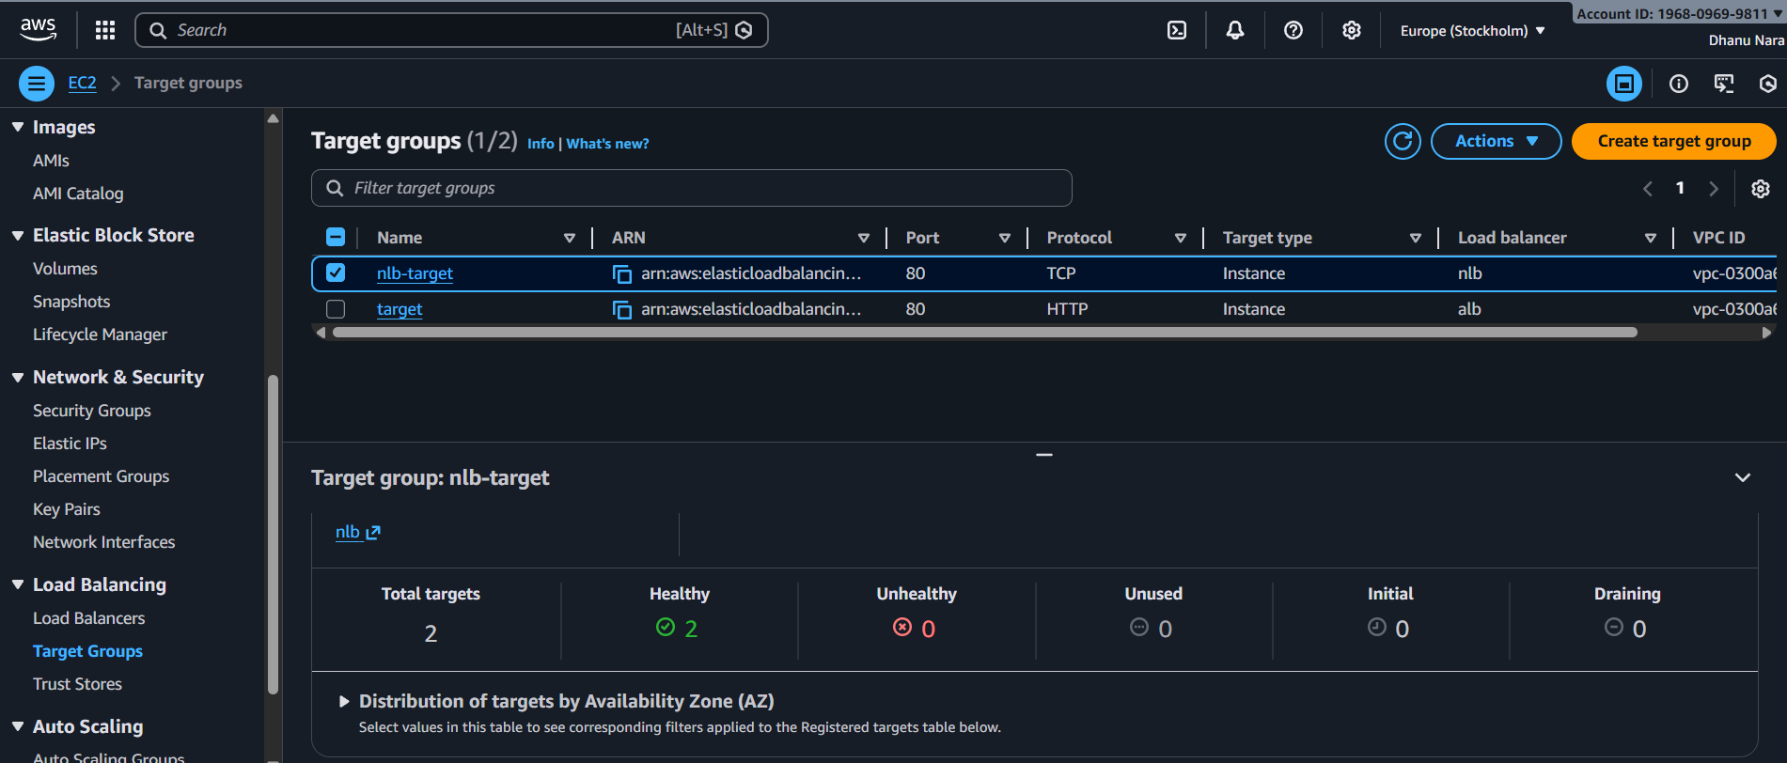

Created Network Loadbalancer

Now in browser paste the DNS of Network Load balancer first it will show the first EC2 content and after refreshing it should show the second EC2 content.

CONCLUSION: A Network Load Balancer delivers ultra-low-latency, high-throughput traffic handling at Layer 4, ensuring scalable and highly available network-level load distribution.

4.Attach SSL for application load balancer.

TITLE:

SSL for Application Load Balancer

OBJECTIVE:

To secure client-to-application communication by encrypting traffic using HTTPS at the Application Load Balancer.

PREREQUISITES:

EC2 instances with service running in it

Target groups

SSL certificate

Application Load Balancer

STEP-BY-STEP-IMPLIMENTATION:

Two instances with httpd running in it

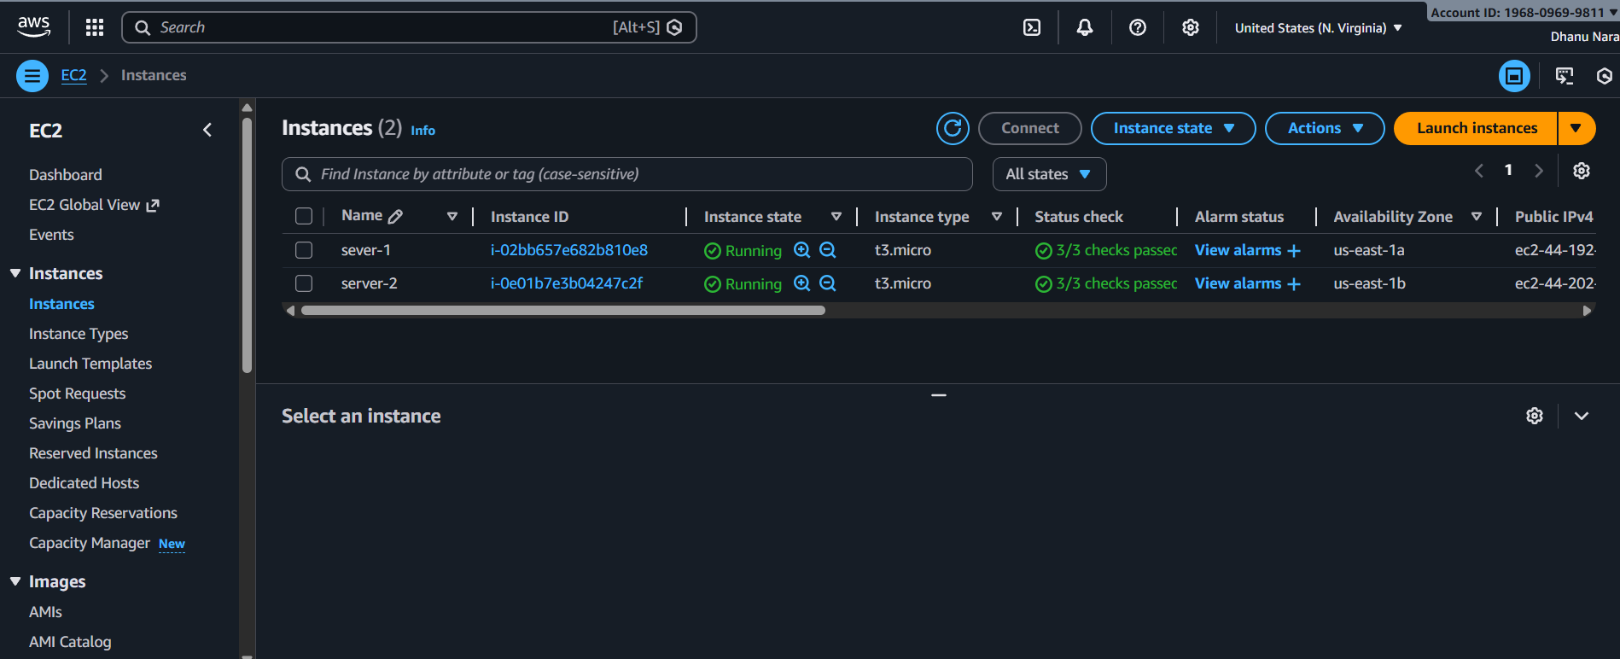

Target group

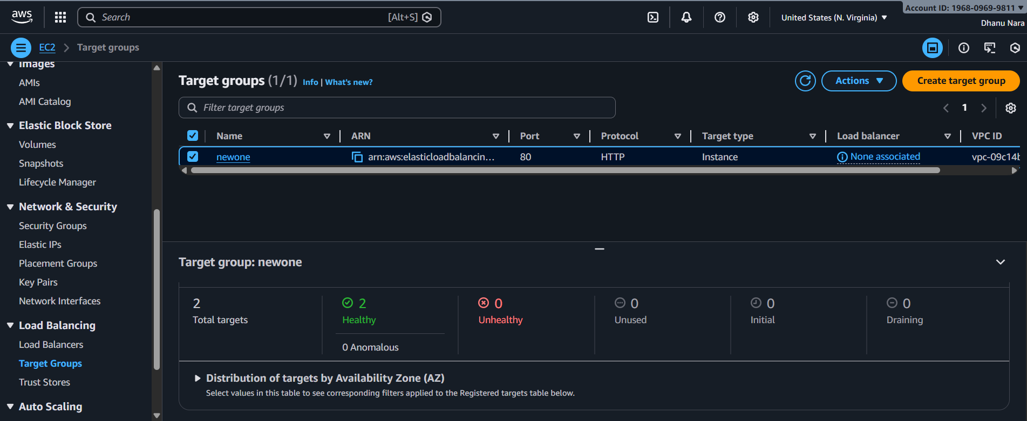

Created Application Load Balancer

Request one SSL certificate from ACM

Attach that certificate in listeners

Now browse with domain name





CONCLUSION: Attaching SSL to a load balancer secures client-to-application communication by encrypting data in transit and enabling trusted HTTPS access.

5.Map Application Load Balancer to R53.

TITLE:

Application Load Balancer mapping to r53

OBJECTIVE:

To route user traffic from a custom domain name to the Application Load Balancer using DNS for reliable and scalable access

PREREQUISITES:

EC2 Instances with service running in it

Target groups

Application Load Balancer

Hosted zone in R53

STEP-STEP-IMPLIMENTATION:

EC2 Instances with httpd running in it

Created target group

Application Load Balancer

Hoste zone in R53

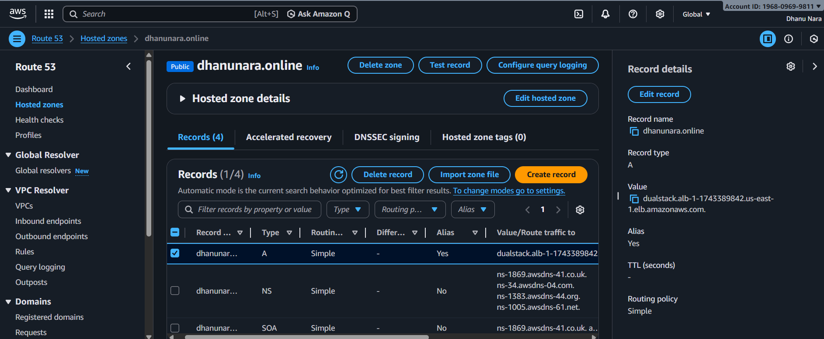

Create record

Now browse with Domain name





CONCLUSION: Mapping an Application Load Balancer to Route 53 enables users to access the application through a friendly domain name while providing reliable DNS-based traffic routing and high availability.

6.Push the Application Load Balancer logs S3.

TITLE:

Application Load Blancer logs to S3

OBJECTIVE:

To store Application Load Balancer access logs in Amazon S3 for centralized request analysis, security auditing, troubleshooting, and long-term retention.

PREREQUISITES:

Application Load Balancer

S3 Bucket

STEP-BY-STEP-IMPLIMENTATION:

Create bucket

Add bucket policy

Create Application Load Balancer attribute

Access logs of application load balancer

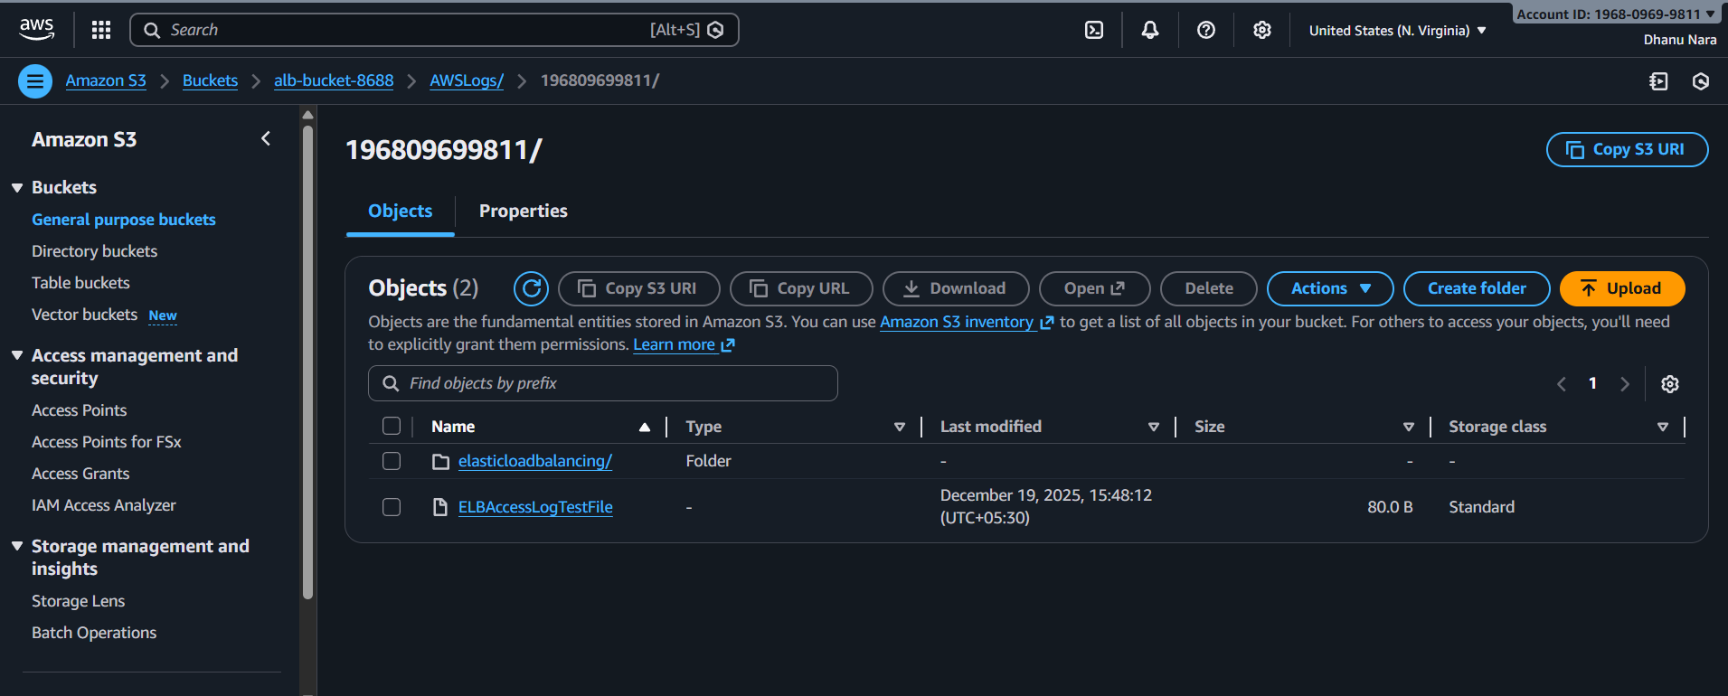

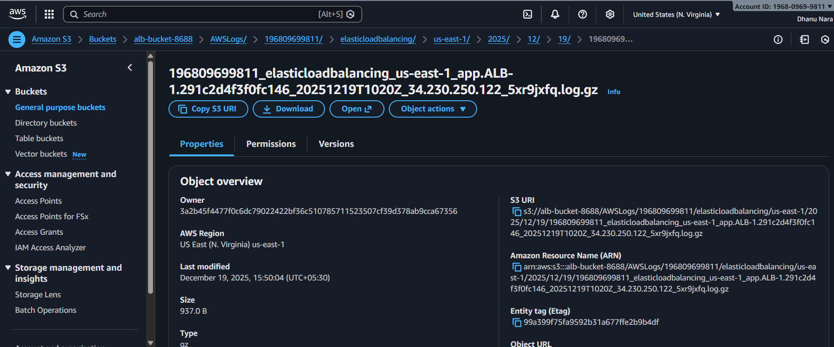

CONCLUSION: Pushing Application Load Balancer logs to Amazon S3 enables centralized storage for monitoring traffic patterns, troubleshooting issues, and meeting security and compliance requirements.